Unit 08 Problem Set Submission Form

# Overview

|  |  |
| --- | --- |
| Your Name | Hrishikesh Telang |
| Your SU Email | hmtelang@syr.edu |

# Instructions

Put your name and SU email at the top. Answer these questions all from the lab. When asked to include screenshots, please follow the screen shot guidelines from the first lab.

Remember as you complete the problem sets it is not only about getting it right / correct. We will discuss the answers in class so it’s important to articulate anything you would like to contribute to the discussion in your answer:

* If you feel the question is vague, include any assumptions you've made.
* If you feel the answer requires interpretation or justification provide it.
* If you do not know the answer to the question, articulate what you tried and how you are stuck.

This how you receive credit for answering questions which might not be correct.

# Questions

Answer these questions using the problem set submission template. You will need to provide a screen shot for each answer. Please follow the guidelines for submitting a screenshot.

1. Provide a screenshot of your completed logical model from Walkthrough Step 2.  
   Graphical user interface, application, Teams

   Description automatically generated
2. Provide a screenshot of your completed logical model from Walkthrough Step 3.  
   Graphical user interface, application, Teams

   Description automatically generated
3. Map this conceptual model to a logical model.   
   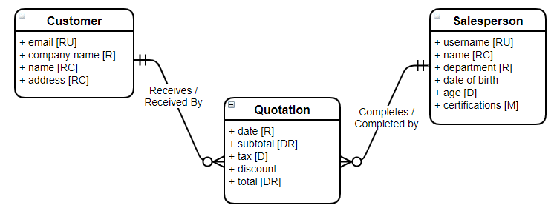

1. Map this conceptual Model to a logical Model  
   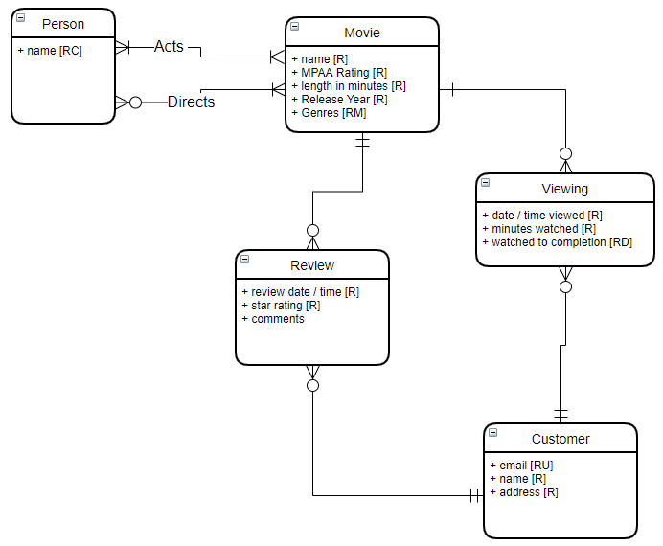

1. Map this conceptual model to a logical data model  
   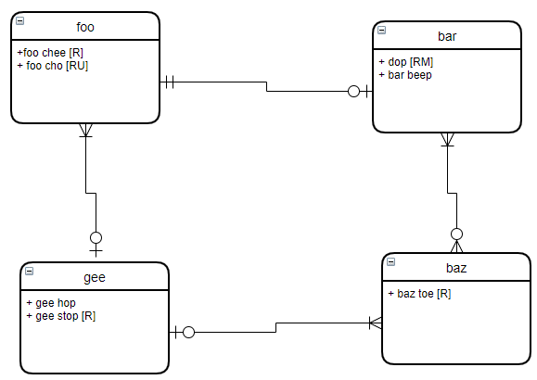

1. Write an SQL Up/Down script to create the tables, keys and constraints for the logical model you created in question 1. Create the tables first with table constraints. Then alter the tables and add the FK constraints. The down part of your script should do this in reverse.

# Reflection

Use this section to reflect on your learning. To achieve the highest grade on the assignment you must be as descriptive and personal as possible with your reflection.

1. What are the key things you learned through the process of completing this assignment?  
   **I learned all the concepts and the right way to implement Logical Data Modelling from the given Conceptual Data Model using the draw.io software**
2. What were the challenges or roadblocks (if any) you encountered on the way to completing it?  
   **At first I was unable to conceptualize the logical data model from the conceptual data model and implement it accordingly. However, with external readings, I was able to implement the whole diagram.**
3. Were you prepared for this assignment? What can you do to be better prepared?  
   **Yes I was prepared for the assignment as I read the unit and watched Prof Michael Fudge’s video before solving the assignment.**
4. Now that you have completed the assignment rate your comfort level with this week’s material. This should be an honest assessment: (choose one)  
     
   4 ==> I understand this material and can explain it to others.  
   3 ==> I understand this material.  
   **2 ==> I somewhat understand the material but sometimes need guidance from others.**  
   1 ==> I understand very little of this material and need extra help.